Profile: Afghanistan
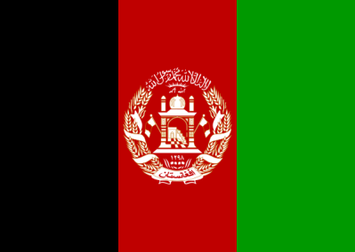

This is a profile of Afghanistan. It is one of the poorest country in the region of Asia. The GDP of Afghanistan is approximately 20.31 million dollars per year.

Exports | %
Grapes | 9.72
Raw cotton | 14.52
coal | 10.52
Iron scarp | 9.18
Insects resins | 7.2

Regional Economies
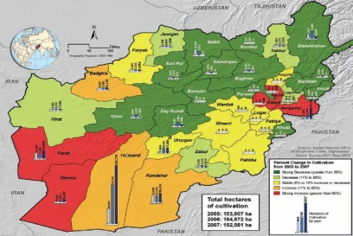
Country | GDP | Main Exports
China | 9.24 trillion | Electronics, clothing, machines
Iran | 368.9 billion | Petroleum, ethylene polymers
Pakistan | 232.3 billion | Cotton, textiles, clothing
Afghanistan | 20.31 billion | Grapes, iron, raw cotton

The highest GDP of this regional economy is China. The region is dominated by China. However, the other countries in the region are strong. Afghanistan is behind the other countries in exports and GDP.

